## CHERRY IN LINE

**Chapter 5**

**Findings, Results, and Analysis**

5.3. FIRE PROTECTION AND SAFETY (FDAS) AUDIT

5.3.1 Fire alarm and detection system

No fire alarm detection system was installed in this booster station

5.3.2 Lightning protection system

There is a lightning protection system installed for this in line booster. The strike counter has not registered a single strike. The bare copper wire connecting the lightning arrester to the ground is already dark and corroded.

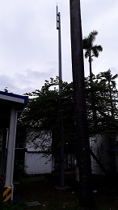 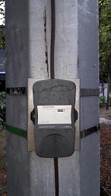 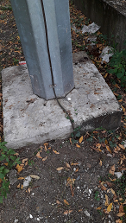

a. Lightning arrester rod b. Strike Counter c. Bare copper wire

5.3.3 Ground-Fault circuit interrupter (GFCI) or electric leakage circuit breaker (ELCB) or Residual circuit devices (RCD)

No GFCI or ELCB or RCD were installed in this booster station.

5.3.4 Electrical safety and protective devices APSI to write here the ﬁndings.

**ELECTRICAL SAFETY**

The pump room is only manned by one person. The old pump room was not maintained and not organized. Staying inside the pump room poses danger to the operator because of the open wiring and exposed live parts. There is only entrance and exit.

|  |  |  |  |  |
| --- | --- | --- | --- | --- |
| **ITEM** | **VISUAL CHECK** | **YES** | **NO** | **COMMENTS** |
| 1. | EVACUATION PLAN |  | X | Pump station is not equipped with all of the standard safety features and equipment |
| 2. | FIRE EXTINGUISHERS |  | X |
| 3. | FIRE EXITS |  | X |
| 4. | FIRE HOSE CABINET |  | X |
| 5. | FIRE SPRINKLER SYSTEM |  | X |
| 6. | EMERGENCY EXIT SIGNAGES |  | X |
| 7. | EMERGENCY LIGHTS |  | X |
| 8. | PPE CABINET |  | X |

|  |  |  |  |  |  |
| --- | --- | --- | --- | --- | --- |
| **ITEM** | **DESCRIPTION** | **YES** | **NO** | **Findings During Inspection** | **Comments** |
| 1. | RUSTY HINGE ON DOOR |  | X | -Broken Hinge of the door | -Unsafe  -Door will not be aligned and hard to close  - Small animals may get inside |
| 2. | UNMAINTAINED DOOR |  | X | -Rusty door opening  - Room not secure  -Evidence of not observing cleanliness | -Unsafe  -Operator is staying inside the room  -unclean environment |

|  |  |  |  |  |  |
| --- | --- | --- | --- | --- | --- |
| 3. | LADDER |  | X | - unprotected ladder going to reservoir  -tree leaves blocking the ladder | -Unsafe  -People climbing should be protected by cage when climbing  -leaves can retain water adding to slippage |
| 4. | OUTDOOR STAIRS |  | X | - No hand rail | -Unsafe  -Possible slipping of operator when going up the steps specially after rain pour or when there is drizzle |

|  |  |  |  |  |  |
| --- | --- | --- | --- | --- | --- |
| 5. | WATER INSIDE  STRUTURE |  | X | - Water ponding inside the structure | -Unsafe  -Water can be breeding for mosquitos if not drained |

|  |  |  |  |  |  |
| --- | --- | --- | --- | --- | --- |
| 6. | DEFECTIVE LIGHTING  FIXTURE |  | X | -Lighting fixture is without bulb (not functioning) | -Unsafe  - Can be a source of fire when ignited and not stored properly.  -Room where the operator stays is not well lit during the night |

|  |  |  |  |  |  |
| --- | --- | --- | --- | --- | --- |
| 7. | OLD STRUCTURE |  | X | - Room was disorganized with a lot of materials and devices stored inside the room where the operator stays. | -Unsafe  - Can be a source of fire when ignited and not sored properly. |
| 8. | Hanging wires |  | X | - Wires from the Room were not harnessed or inside conduit | -Unsafe  - Exposed wires Still with power and can be a source of fire hazard. |

|  |  |  |  |  |  |
| --- | --- | --- | --- | --- | --- |
| 9. | Hanging wires |  | X | - Wires from the Room were not harnessed or inside conduit.  -Visible deterioration of wires | -Unsafe  - Exposed wires are Still with power and can be a source of fire hazard. |

|  |  |  |  |  |  |
| --- | --- | --- | --- | --- | --- |
| 10. | Hanging wires |  | X | - Wires from the Room were not harnessed or inside conduit  -visible deterioration of wire insulation | -Unsafe  - Still with power and can be a source electrocution and of fire hazard. |

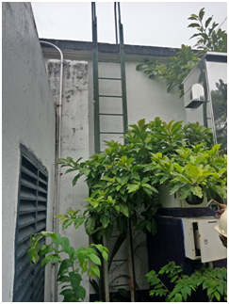

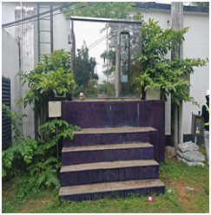

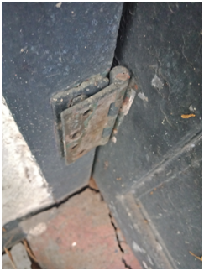

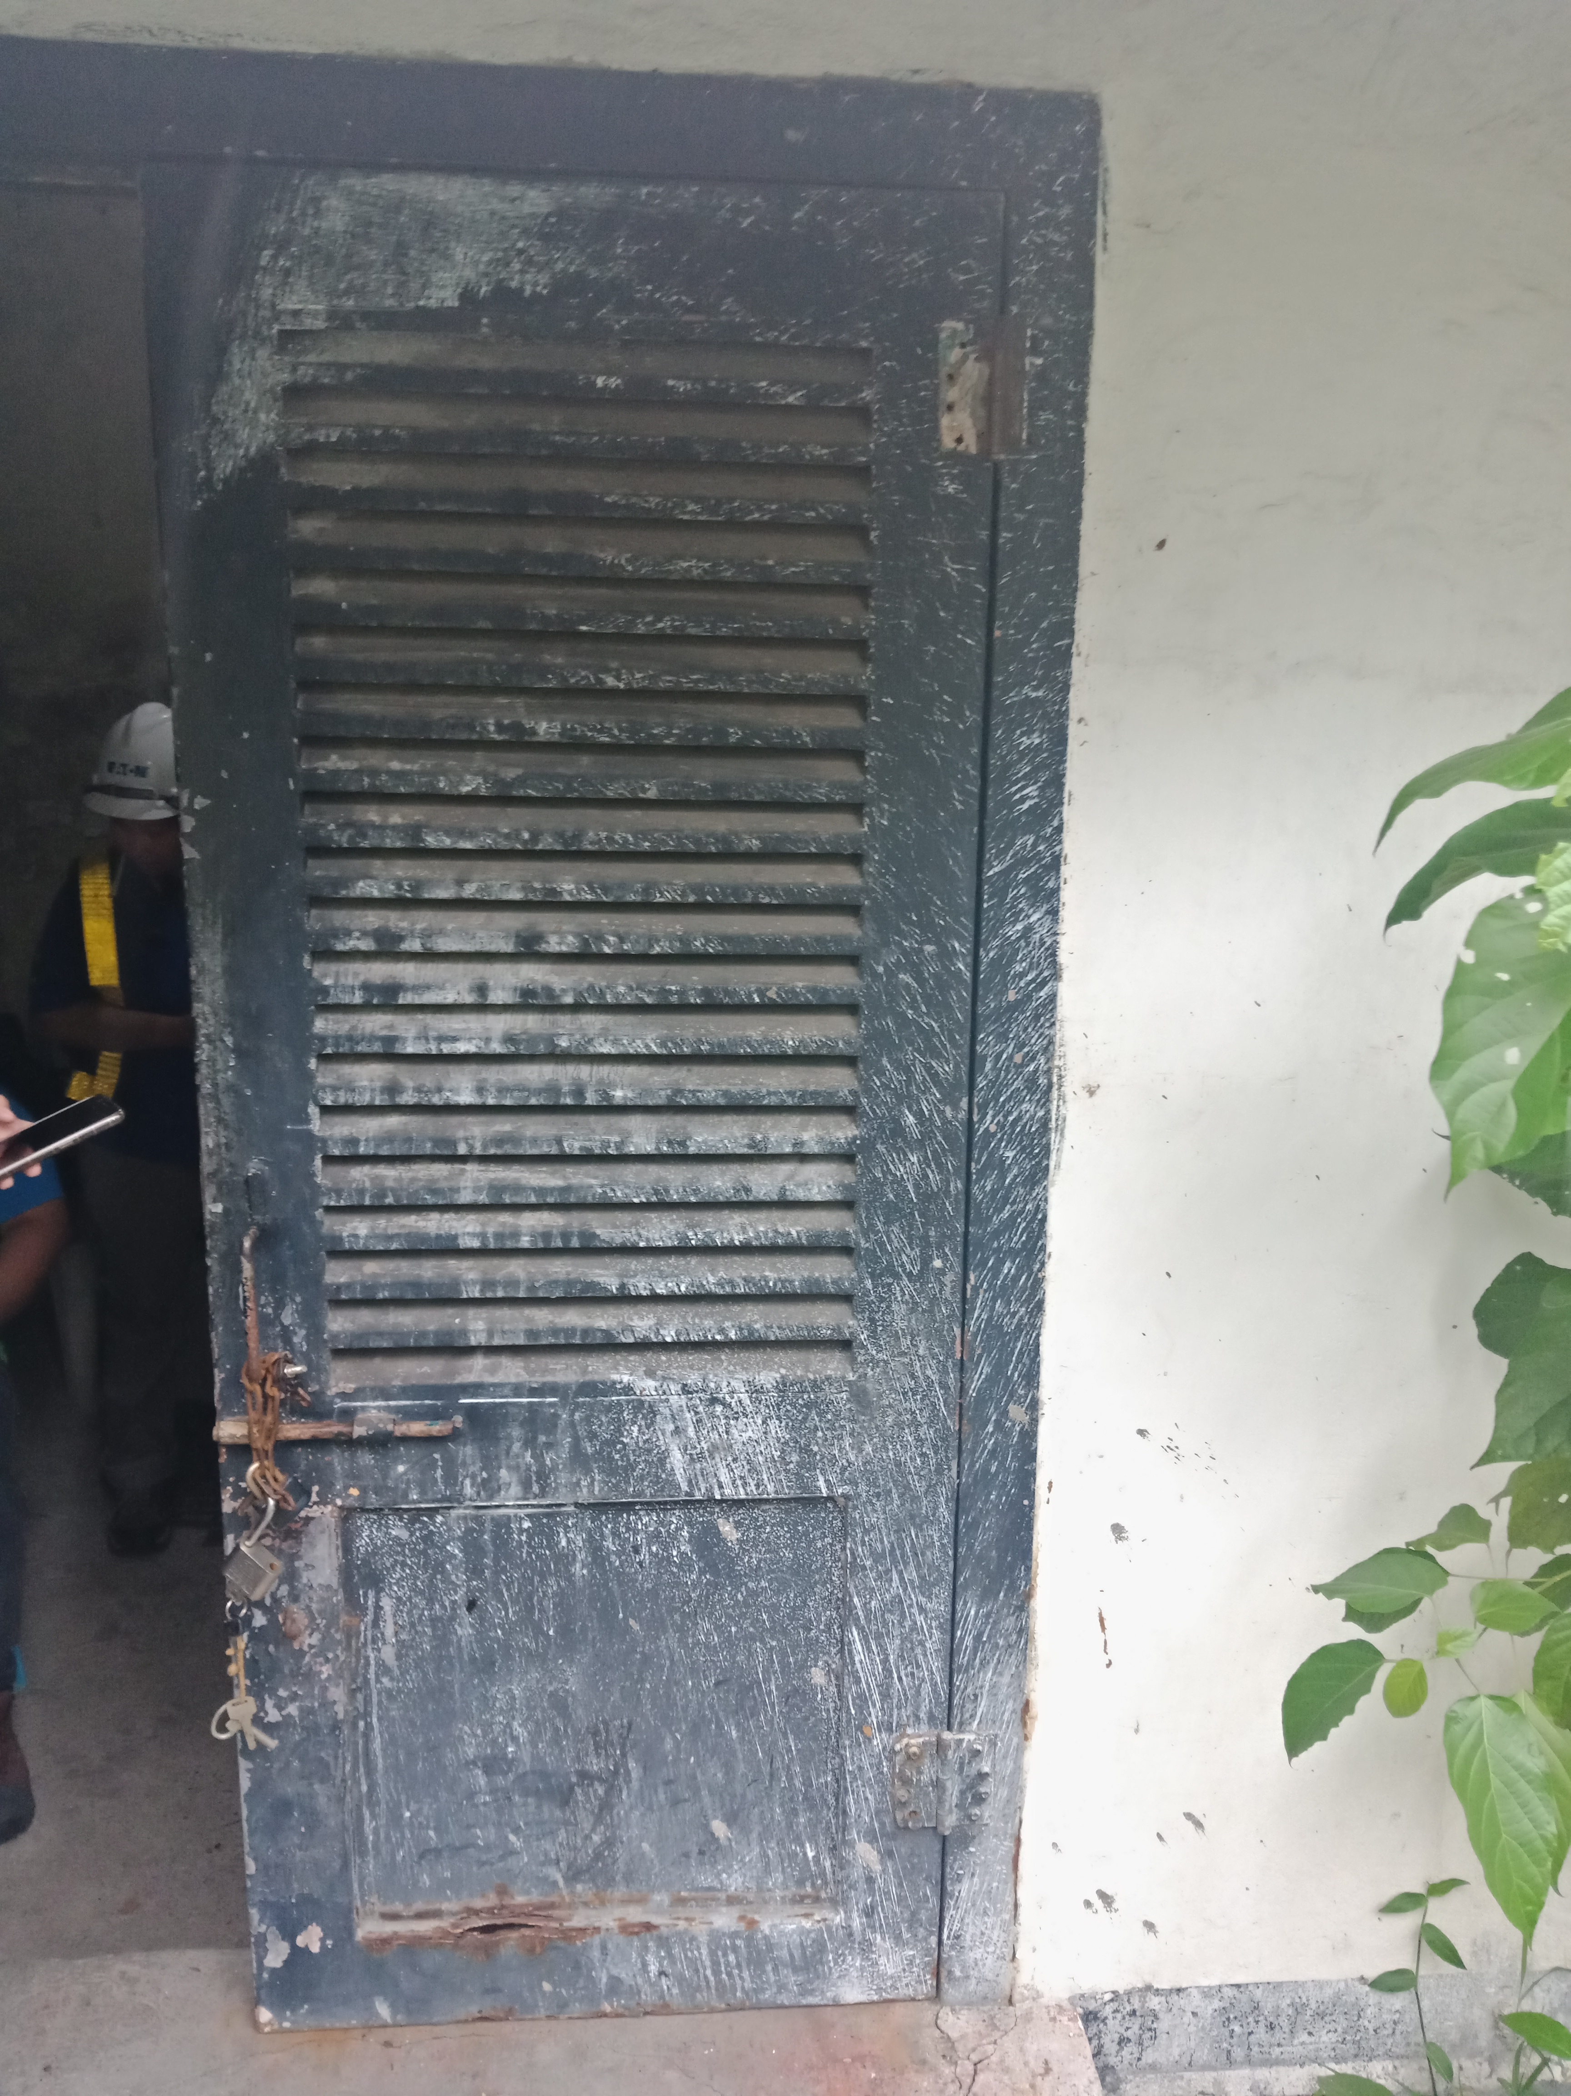

a. Rusted Hinge on Door b. broken door

c. Unprotected Ladder d. Stairs with handrail

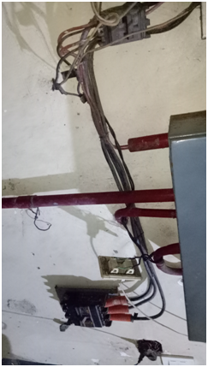

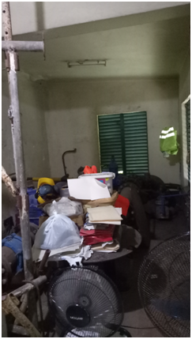

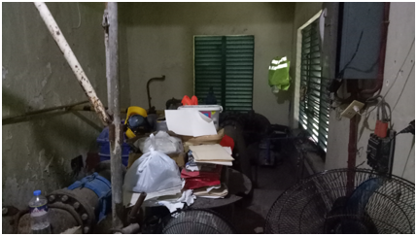

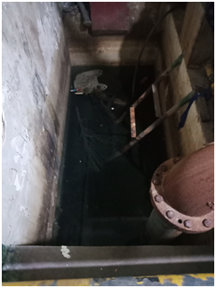

e. Water ponding f. Defective Lighting g. Disorganized Room h. Hanging wires

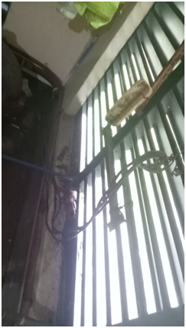`

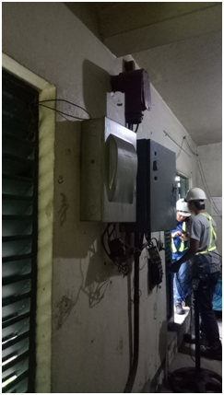

i. Hanging Wires j. Hanging Wires

**Chapter 6**

**Conceptual Design and Outcomes**

6.1 Basis of Design

|  |  |  |  |  |
| --- | --- | --- | --- | --- |
| **ITEM** | **Drawings** | **YES** | **NO** | **COMMENTS** |
| 1. | Existing As-built drawings for FDAS |  | **x** | There was no FDAS installed |
| 2. | Existing As-built drawings for Emergency light location |  | **x** | There was no EL installed |
| 3. | Existing As-built for Fire Extinguisher location |  | **x** | There was no FEX seen in the area |

Recommendation: The area where the operator stays should be maintained and improved, free from all obstructions and address safety issues. The workplace should observe good housekeeping and maintain cleanliness at all times.